URRICULUMVITA
v
c
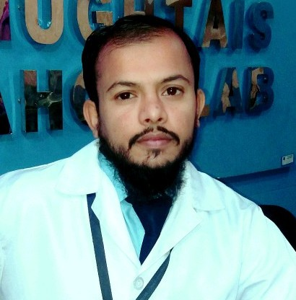

GHULAM MUSTAFA
Cell #: +92-3013602208 +923450341917
E-mail: =Mustafamalik72@gmail.com
Personal Information:
Father’s Name: Ghulam Nabi
Date of Birth: 05-12-1990
Domicile Rahim Yar Khan (Punjab)
Nationality: Pakistani
Marital Status Married
Religion: Islam
CNIC No. 31304-7315767-7
Address: Bashir Colony Street No:02
Sadiqabad District Rahim yar khan
Qualification:
Certificate/Degree | Year | Division | Board/University
Matric | 2006 | 1st | BISE BAHAWALPUR
F.A(Arts) | 2015 | 1st | Allama Iqbal open University
B.A(Arts) | 2018 | 1st | Allama Iqbal open University

PROFESSIONAL EXPERIENCE
- Worked as as a“Assistant lab technician” in The care Medical Lab
- 7 year experience as a “F.D.O”and phlebotomist in Chughtais Lahore lab and still working on...

Phlebotomy Skills:

Delivering kind and attentive service to patients of all ages.
Consummately professional phlebotomist with 7 years’ experience within physicians’ office and hospital settings. Apply keen attention to detail to ensure proper collection and labeling of all blood & Covid-19 samples.
Key skills include:
- Venipuncture / Capillary Blood Collection
- Empathetic Customer Service
- Excellent Communication Skills
- Specimen Preparation
- Medical Records Data Entry / Coding
- Insurance / Payment Processing

Computer Skills:

- DOM(Diploma of Office management)
- WINDOW XP, 7, VISTA, 98.
- Typing speed 30 wpm
- Internet

Language skills:

- Command on local language English,Saraiki,urdu and Punjabi

Job Responsibilities:

- Computer operator
- Reception controlling
- To keep up-dated information regarding any alternation in protocol
- Deposit Cash in to the bank
- Day to Day expense detail
- Accurate data entry
- To receive Mails and Update the filing record accordingly.
- To maintain the proper record of all cash
- To attend phone calls and to provide the appropriate guidance to the patients.
- Full command on Nexus pro(The ultimate solution)

Reference:

- Will be provided on Demand.

